**Project Report**

**On**

**“IOPE DIARIES”**

**Submitted to:**

**DR. BABASAHEB AMBEDKAR TECHNOLOGICAL UNIVERSITY**

**(DIPLOMA WING)**



**Submitted by:**

**PAWAR SEJAL RAVINDRA (2201967)**

**JADHAV MANISH SHASHIKANT (2201933)**

**GURAV SHRUTI SANJAY (2201929)**

**Under guidance of**

**Prof. Aniket. H. Shelake**

**DEPARTMENT OF INFORMATION TECHNOLOGY**

**DR. BABASAHEB AMBEKAR TECHNOLOGICAL UNIVERSITY**

**(DIPLOMA WING), LONERE**

**Academic Year 2022-23**

**DR. BABASAHEB AMBEDKAR TECHNOLOGICAL UNIVERSITY** **(Diploma Wing)**

Lonere- 402103, Tal. Mangaon, Dist. Raigad

**DEPARTMENT OF INFORMATION TECHNOLOGY**

**CERTIFICATE**

It is certified that the Project entitled

**“IOPE DIARIES”**

Submitted by:

**PAWAR SEJAL RAVINDRA (2201967)**

**JADHAV MANISH SHASHIKANT (2201933)**

**GURAV SHRUTI SANJAY (2201929)**

A Bonafide work carried out under the supervision of Prof. Aniket. H. Shelake, It is submitted towards the partial fulfilment of the requirement of University of Dr. Babasaheb Ambedkar Technological University, Lonere for the award of the degree of Diploma in Information Technology.

**_________________ _________________ _________________**

**Prof. A. H. Shelake Prof. K. R. Korpe Prof. S. M. Gaikwad**

**(Project Guide) (Project Coordinator) (Head of Department[I.T])**

**External Examiner:**

**_________________**

**Place:** Dr. Babasaheb Ambedkar Technological University (Diploma Wing), Lonere.

**Date:**

It is indeed a great pleasure of us to present this project report. This pleasure would not be have without the support extended by our guide **Prof. Aniket. H. Shelake**, Information Technology Department, Institute of Petrochemical Engineering, DR. BABASAHEB AMBEDKAR TECHNOLOGICAL UNIVERSITY, Lonere, who not only encouraged us through the venture but also to grate points in going through the manuscript carefully and correction which have greatly improved the quality of the text.

I am also thankful to all lecturers of Information Technology Department and staff of college for their valuable guidance.

Last but not the least I would like to thanks my colleagues and all those who have contributed directly or indirectly in development and evolution of this project report.

THANK YOU!

The Event Project is a web-based application designed to streamline the management and presentation of events within a college environment. This report presents the development and implementation of a dynamic platform that allows administrators to upload event details and associated images, which are then seamlessly displayed in the user event section. Furthermore, when users click on a specific event, they can access a comprehensive description and a collection of relevant event images.

The primary objective of the Project **“IOPE Diaries”** is to enhance the accessibility and engagement of college events for both administrators and users. By providing a centralized system for event management, administrators can efficiently upload event details, including the event name, description, Department which conducted it, and other pertinent information. Additionally, administrators can upload high-quality images that capture the essence of each event, enriching the visual experience for users.

In the user event section, individuals can easily navigate through a list of past events. When a user selects a particular event, they are presented with a detailed description that provides a comprehensive overview of the event's purpose, agenda, and any special features. Moreover, a visually appealing gallery of event images allows users to gain a deeper understanding of the event atmosphere and highlights.

The development of the Event Project involved employing modern web technologies, such as HTML, CSS, and JavaScript, along with appropriate backend frameworks for handling data storage and retrieval. The application's architecture incorporates user-friendly interfaces and intuitive navigation, ensuring a seamless experience for both administrators and users.

The successful implementation of the Event Project has demonstrated its potential to revolutionize event management within college environments. By centralizing event information and imagery, the platform promotes efficient communication and engagement among students, faculty, and other stakeholders. This report provides insights into the design, development, and functionality of the Event Project, highlighting its numerous benefits and potential for future enhancements.

CERTIFICATE ii

ACKNOWLEDGEMENT iii

ABSTRACT iv

1. INTRODUCTION 7
   1. Problem Definition 7
   2. Scope & Objective 7
   3. Language & Tools 8
   4. System Requirements 8
2. LITERATURE SURVEY 9
   1. Existing Systems 9
   2. Flaws in Existing Systems 9
   3. Proposed System 10
3. REQUIREMENT ANALYSIS 11
   1. Functional Requirements 11
   2. Non-Functional Requirements 11
   3. Test Criteria 12
4. DESIGN 13
   1. Software Development Life-Cycle (SDLC) Model 13
   2. Diagrams 14
5. User Interface (UI) 21
6. Source Code Snippets 25
7. Meet the TEAM 31

CONCLUSION 33

REFERENCES 34

|  |  |  |  |
| --- | --- | --- | --- |
| **Sr.** | **Fig. No.** | **Name of the Figure** | **Page No.** |
| 1. | 4.1 | Iterative Model (SDLC) | 13 |
| 2. | 4.2 | Flowchart | 14 |
| 3. | 4.3 | Data Flow Diagram Level-0 | 15 |
| 4. | 4.4 | Data Flow Diagram Level-1 | 15 |
| 5. | 4.5 | Entity-Relationship Diagram | 16 |
| 6. | 4.6 | Control Flow Diagram | 17-18 |
| 7. | 4.7 | Use-Case Diagram | 19 |
| 8. | 4.8 | System Architecture | 20 |
| 9. | 5.1 | Home Page | 21 |
| 10. | 5.2 | Course Section | 21 |
| 11. | 5.3 | Log-In Page | 22 |
| 12. | 5.4 | Admin Event Uploading Page | 22 |
| 13. | 5.5 | Event Form | 23 |
| 14. | 5.6 | Admin Image Upload Page | 23 |
| 15. | 5.7 | User side Event Section | 24 |
| 16. | 5.8 | Details of a particular event | 24 |
| 17. | 6.1 | HTML | 25 |
| 18. | 6.2 | PHP | 26 |
| 19. | 6.3 | Connection File | 27 |
| 20. | 6.4.1 | Database | 28 |
| 21. | 6.4.2 | Database (Events Table) | 28 |
| 22. | 6.4.3 | Database (Images Table) | 29 |
| 23. | 6.5.1 | Log-In Logic | 29 |
| 24. | 6.5.2 | Log-In Logic (Database) | 30 |
| 25. | 7.1 | Project Meetings | 32 |

## LIST OF TABLES

|  |  |  |  |
| --- | --- | --- | --- |
| **Sr.** | **Tab. No.** | **Name of the Table** | **Page No.** |
| 1. | 3.1 | Test Criteria Table | 12 |

## INTRODUCTION

#### “IOPE Diaries”



**IOPE Diaries**

#### Problem Definition:

* + - **Problem Statement:** Designing an effective college event website that caters to the needs of both students and faculty, while ensuring seamless navigation and optimal user experience, is a challenging task. The website must provide comprehensive information about conducted events, relevant details, and should also incorporate features that promote engagement, networking, and community building. The challenge lies in balancing functionality, aesthetics, and usability, while adhering to time and budget constraints.
    - **Relevance:** A college event website is highly relevant as it serves as a centralized hub of information for students, faculty, and staff regarding conducted events and activities on campus. It allows individuals to easily access important details such as event dates, times, locations, and registration information. Additionally, it provides a platform for students to engage with each other and the campus community, fostering a sense of belonging and promoting a vibrant campus culture. By promoting and highlighting the diverse range of events and activities on campus, the website encourages participation, collaboration, and lifelong learning.

#### Scope & Objective:

* + - **Scope:**

1. **Accessibility:** As it is a web-based platform, it can be accessed anytime.
2. **Free-of-cost:** Does not charge for anything.
3. **Event Promotion:** One key scope of a college event website is to promote conducted events on campus.
4. **Analytics and Reporting:** Analytics and reporting can also help demonstrate the impact of events on the campus community and the broader public.

#### C:\Users\tejas\Downloads\start-up.pngObjectives:

1. **Easy-to-use:** Ease of accessing the platform.
2. **Usability:** User Friendly Interface.
3. **Gain:** Confidence to participate in other events.
4. **Promote Campus Culture:** A third objective for a college event website could be to promote campus culture and showcase the diversity of events and activities happening on campus. By highlighting events from a variety of departments and student groups, the website can help create a more vibrant and inclusive campus community.

#### Languages & Tools:

1. **Front End:** HTML, CSS, JavaScript.
2. **Back End:** PHP, MySQL.
3. **Operating System:** Windows 11.
4. **Web Browser:** Google Chrome.
5. **IDE used:** Visual Studio Code 1.63.0
6. **Tools:** Bootstrap.



#### System Requirements:

1. **Screen Resolution:** 1280x1024 or larger
2. **Application Window:** 1024x680 or larger
3. **Operating System:** Windows 8 or later, macOS Sierra 10.12 or later, Ubuntu 14.04+
4. **Web Browser:** Google Chrome (Recommended)
5. **Internet Connection:** Required
6. **Memory:** 2GB Minimum, 4GB Recommended

## LITERATURE SURVEY

#### Existing Systems:



1. **COEP Zest:**

COEP Zest is a site which contains the event registration process of the events conducted in the college. Students from the college can register to the events which are going to be conducted in the college. Cultural events like Freshers, farewell, technical competitions, Sports events, etc.

#### C:\Users\tejas\Downloads\flaw.pngFlaws in Existing System:

1. **No data of conducted events.**

After studying this existing system, it concluded that these site does not have the data of conducted events like event images, etc. Students were accessible for registering/participating in the events but they were unable to view the data of Events.

#### Proposed System:

As a solution to flaws in existing system, we came up with *‘IOPE Diaries* that is:

1. **Student-Oriented.**
2. **Contains data of conducted events.**
3. **Reduces the workload of secretary of storing data of events.**

*‘IOPE Diaries’* provides a potential solution to the problems mentioned above. It is more of a student-oriented platform. The Existing platform provide a registration page but didn’t had data section. By viewing above problem, we decided to build a website for our college which will contain data of conducted events in IOPE. Whereas, using *‘IOPE Diaries’* can be very friendly to the students as well as their parents to view the events images. Also, the workload of secretary of committee to store the data of conducted events.



## REQUIREMENT ANALYSIS

#### Functional Requirements:

1. **Login:**

Admin logins to the system by entering valid user id and password which is already set in the database to upload the events and related information of events.

1. **Event Section:**

The system will provide event list of events from database. Short description and long description are provided with the image.

1. **Test cases result:**

The admin has to pass all the test cases(details required to upload event).

1. **Logout:**

After uploading event admin can logout of system.

#### Non-Functional Requirements:

1. **Security:** The system’s back-end servers shall only be accessible to authenticated administrator. Sensitive data will be encrypted before being sent over internet.
2. **Reliability:** The system’s architecture is made having a focus on user attraction.
3. **Availability:** The system should be available at all times; the user can access it using a desktop or a laptop. It means 24x7 availability.

**Portability:** The application is a web app available and runnable on web browsers.

### Test Criteria:

|  |  |  |  |
| --- | --- | --- | --- |
| **Sr.** | **Functional Test Cases** | **Actual Output** | **Expected Output** |
| 1. | Verify if a admin is able to login with appropriate credentials. | Admin is logged in with system. | Admin logged in successfully |
| 2. | Verify if clicking on login button will redirect to admin panel. | Clicking on particular link is redirecting to proper page | Redirection on proper page |
| 3. | Verify if user is able to access about us, user section, contact us page. | User can access all the three pages | Accessing all three pages |
| 4. | Clicking on Explore our events is redirecting to the event section page where user is able to view events uploaded by admin. | User can view events uploaded by admin. | Viewing events uploaded by admin. |
| 5. | Clicking on DELETE and EDIT button events should be deleted and updated respectively. | Deleting and updating events is possible. | Successfully deleting and updating events. |

**Table. 3.1: Test Criteria Table**



## DESIGN

#### Software Development Life-Cycle (SDLC) Model:

The SDLC Model on which ‘IOPE Diaries’ is based on is ‘Iterative Model’.

#### Iterative Model:

Iterative process starts with a simple implementation of a subset of the software requirements and iteratively enhances the evolving versions until the full system is implemented. At each iteration, design modifications are made and new functional capabilities are added. The basic idea behind this method is to develop a system through repeated cycles (iterative) and in smaller portions at a time (incremental).

The following illustration is a representation of the Iterative and Incremental model −

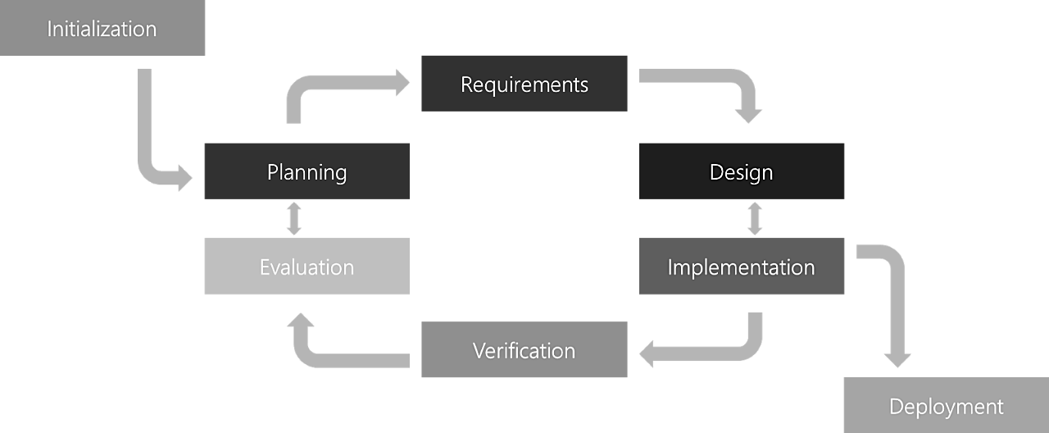

**Fig. 4.1: Iterative Model (SDLC)**

* 1. **Diagrams:**

#### Flow Charts:

#### 

**Fig. 4.2: Flowchart**

* 1. **Data Flow Diagram Level-0:**

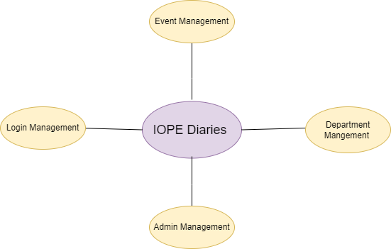

**Fig. 4.3: Data Flow Diagram Level-0**

#### Data Flow Diagram Level-1

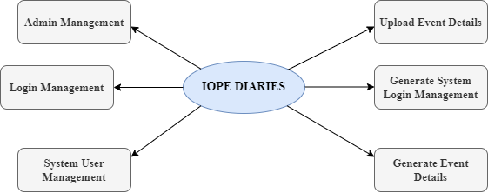

**Fig. 4.4: Data Flow Diagram Level-1**

#### Entity-Relationship Diagram:

#### 

**Fig. 4.5: Entity-Relationship Diagram**

#### Control-Flow Diagram:

* **User-side:**

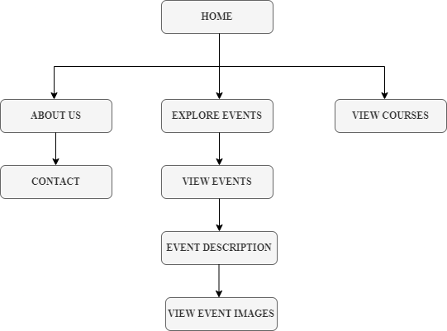

* **Admin-side:**

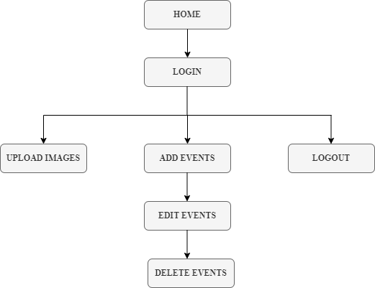

**Fig. 4.6: Control-Flow Diagram**

#### Use-Case Diagram:

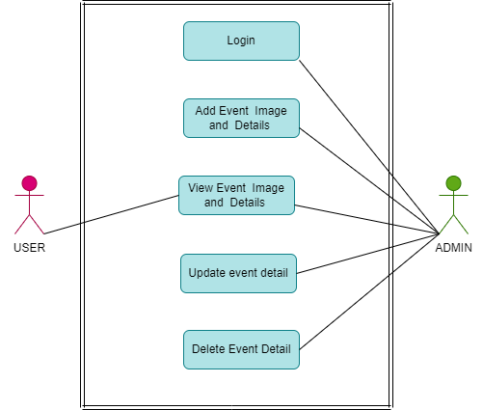

**Fig. 4.7: Use-Case Diagram**

#### System Architecture:

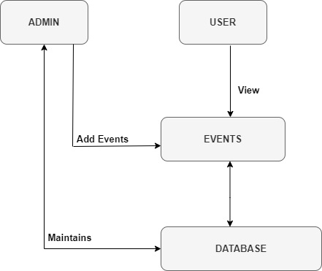

**Fig. 4.8: System Architecture**



**5.USER INTERFACE (UI)**

1. **Home Page:**

**Fig. 5.1: Home Page**

1. **Course Section:**

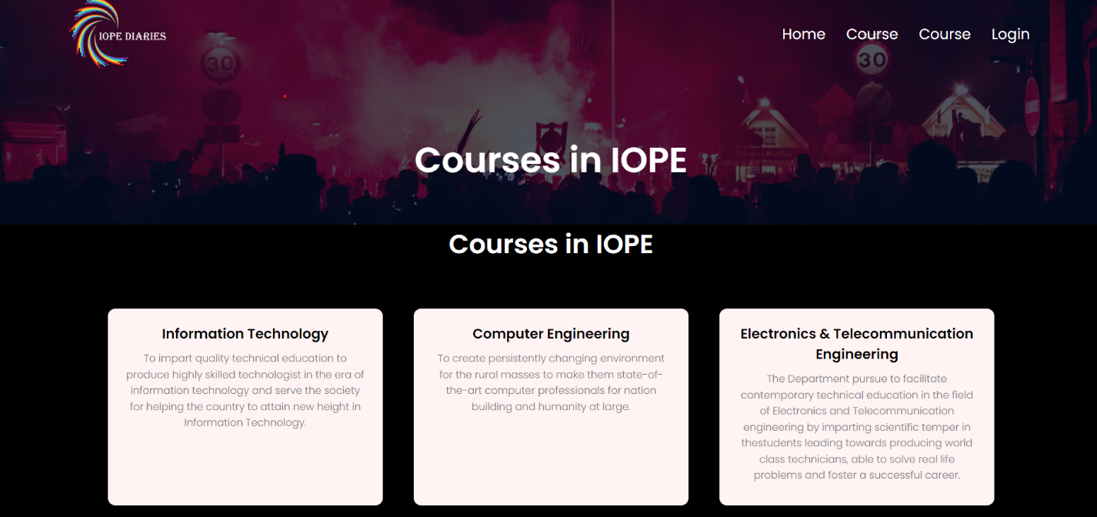

**Fig. 5.2: Course Section**

1. 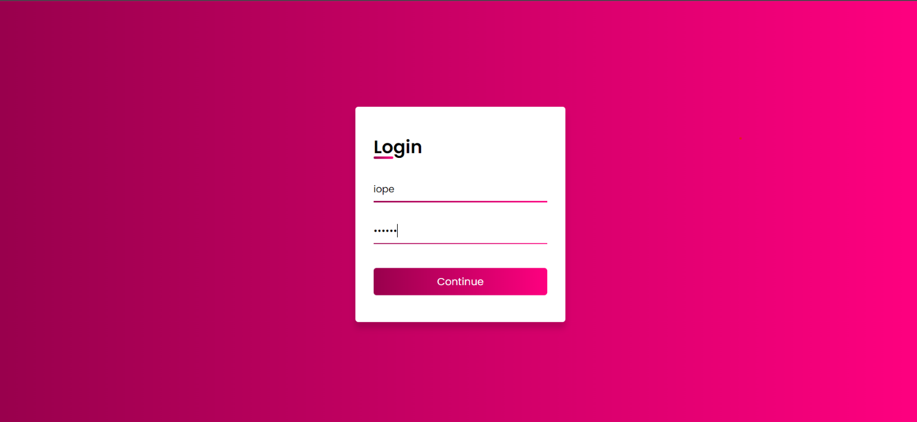**Log-In Page:**

**Fig. 5.3: Log-In Page**

1. 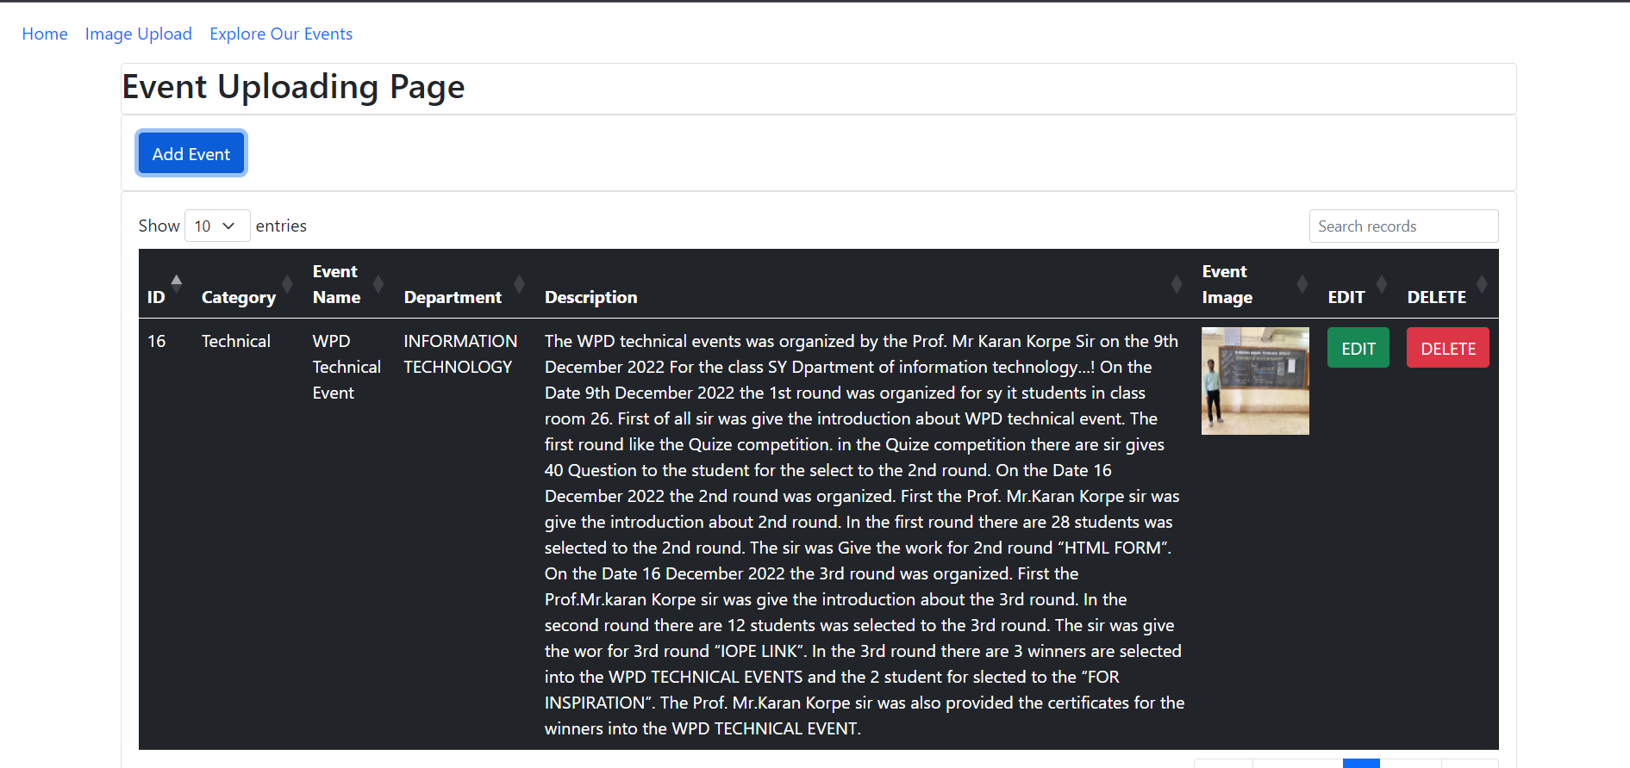**Admin Event Uploading Page:**

**Fig. 5.4: Admin Event Uploading Page**

1. 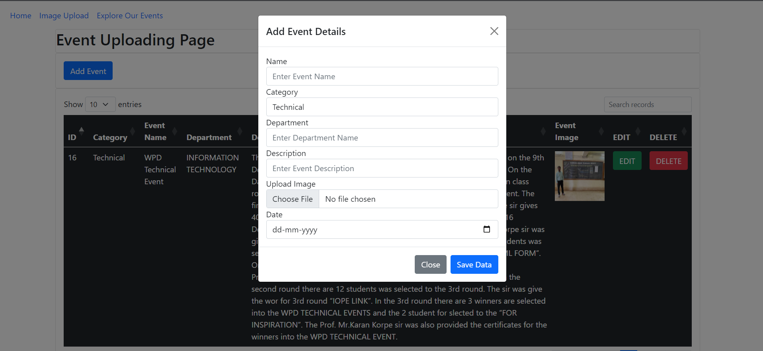**Event Form:**

**Fig. 5.5: Event Form**

1. 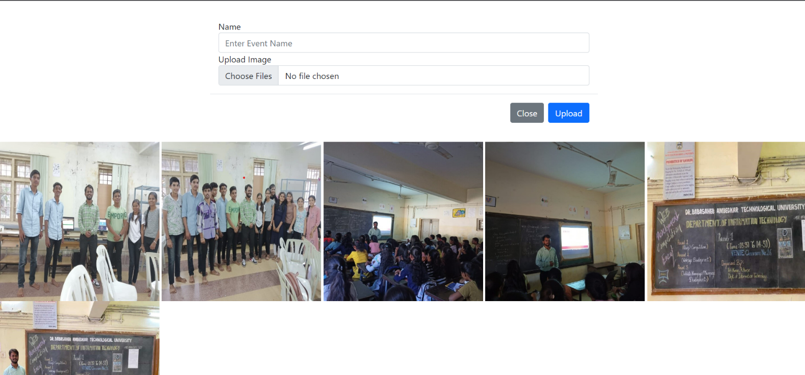**Admin Image Upload Page:**

**Fig. 5.6: Admin Image Upload Page**

1. 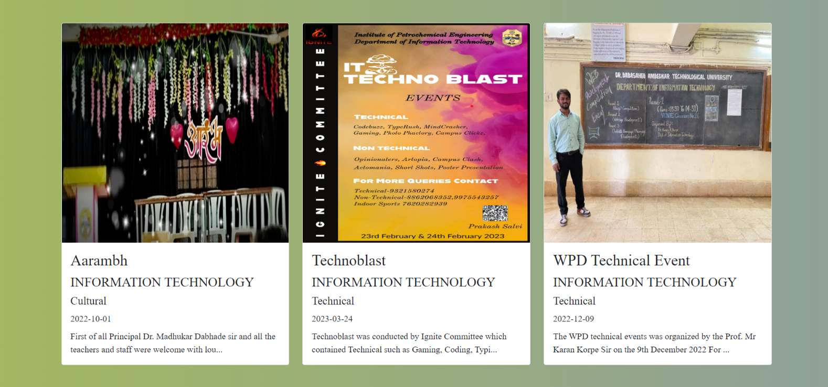**User-side Event Section:**

**Fig. 5.7: User-Side Event Section**

1. 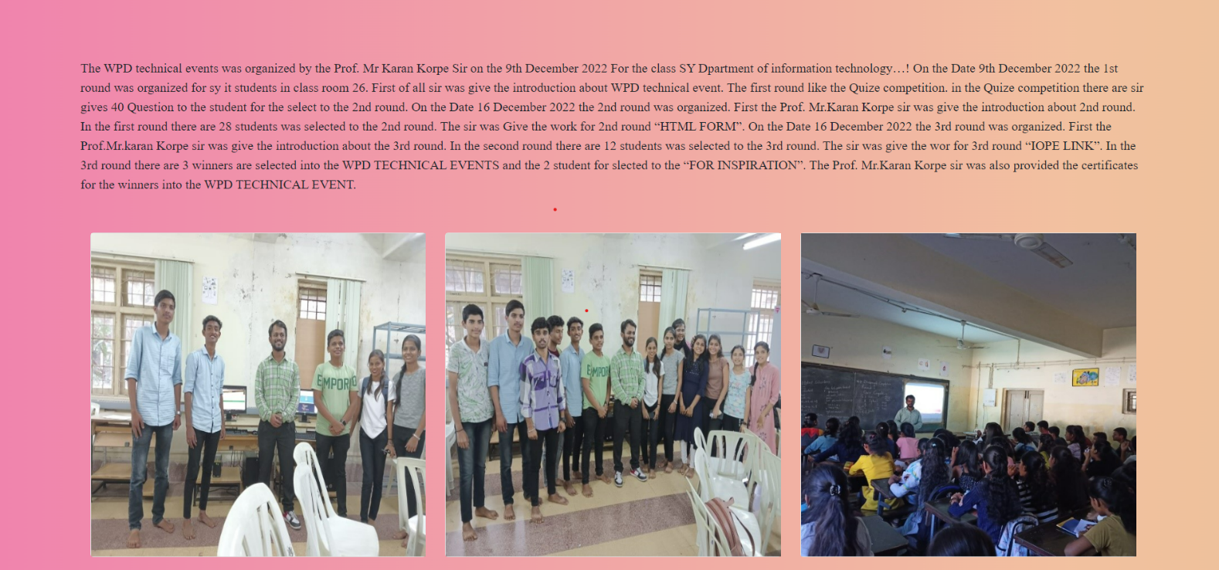**Details of a particular event:**



**Fig. 5.8 Details of a particular Event**

## 6. SOURCE CODE SNIPPETS

#### HTML:

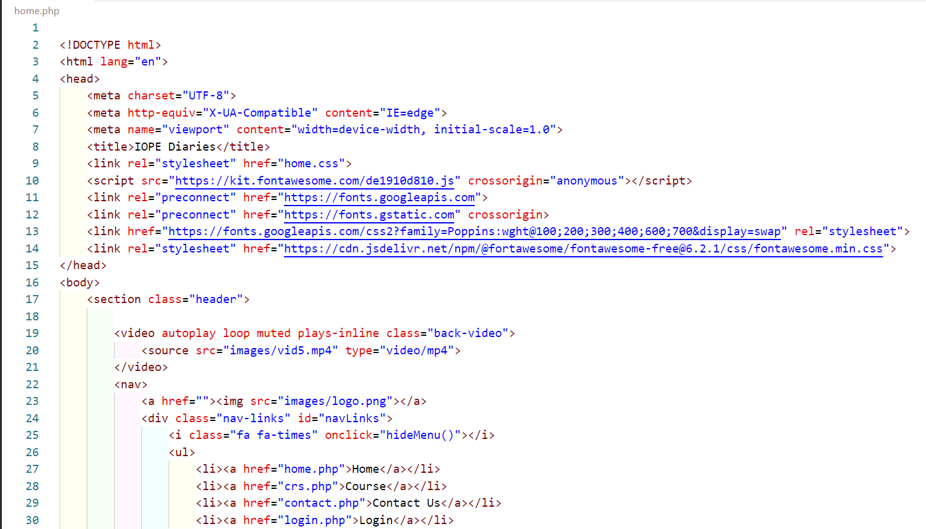

**Fig. 6.1: HTML**

#### PHP:

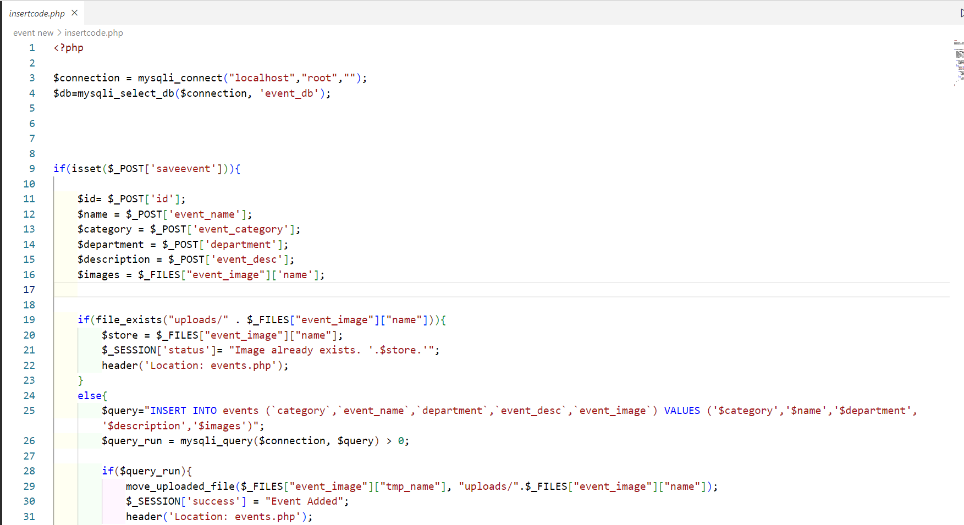

**Fig. 6.2: PHP**



#### Connection File:

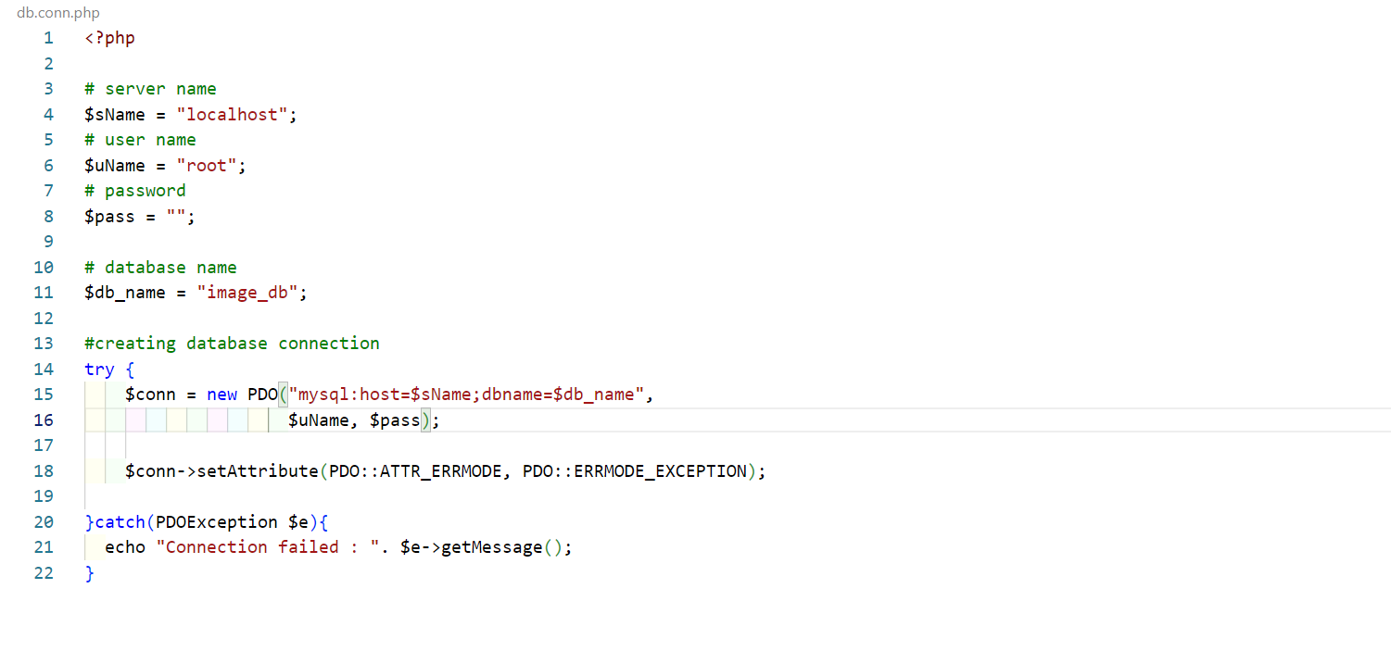

**Fig. 6.3: Connection File**



#### Database:

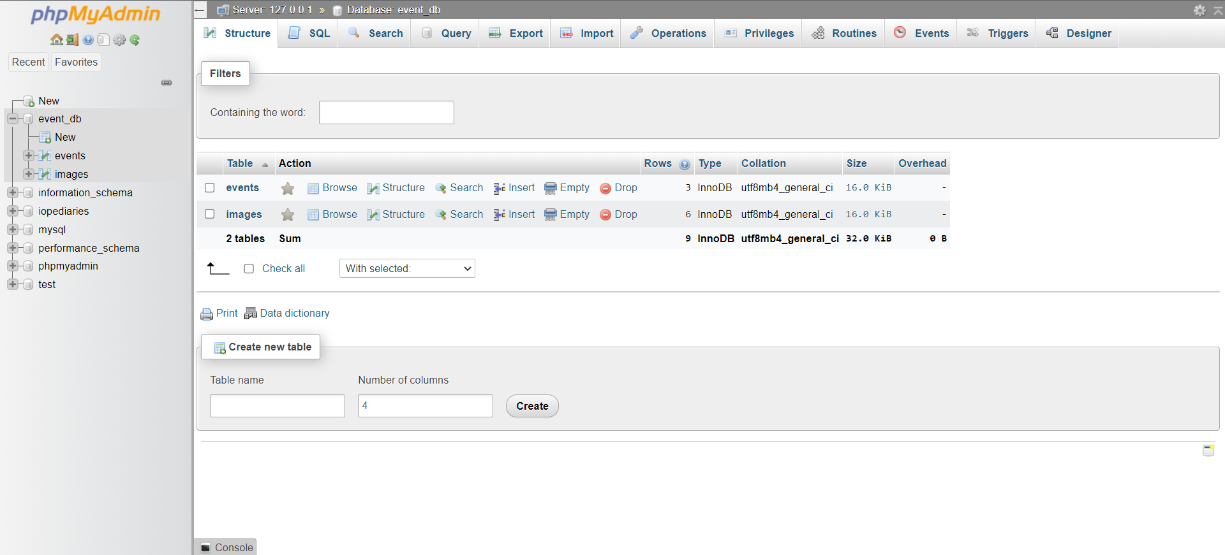

**Fig. 6.4.1: Database**

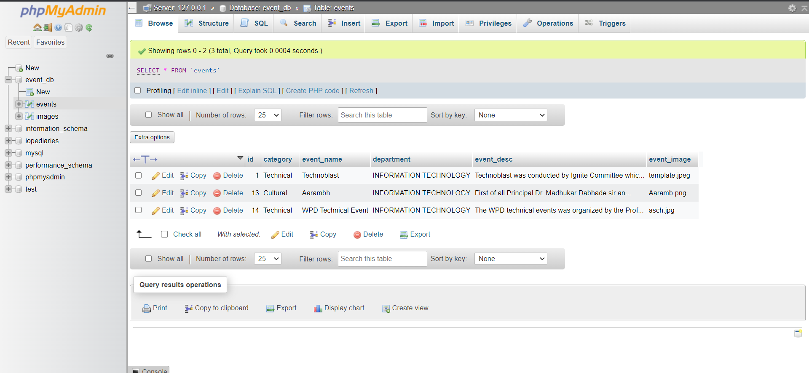

**Fig. 6.4.2: Database (Events Table)**

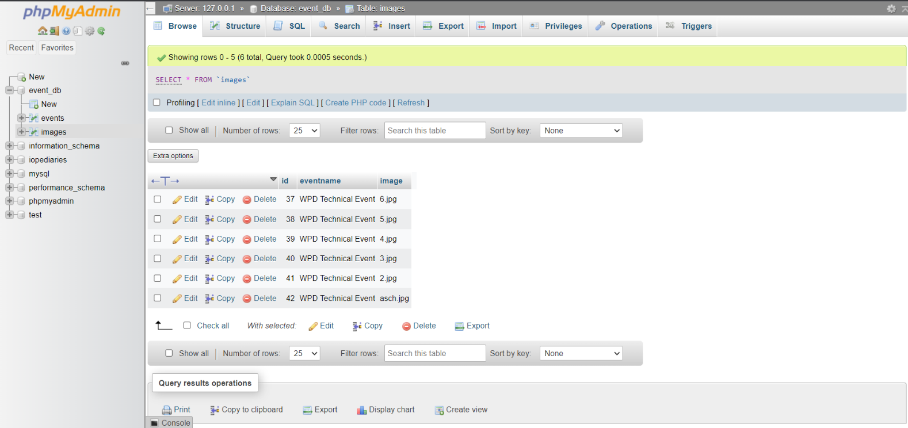

**Fig. 6.4.3: Database (Images Table)**

* 1. **Sign-up Logic:**

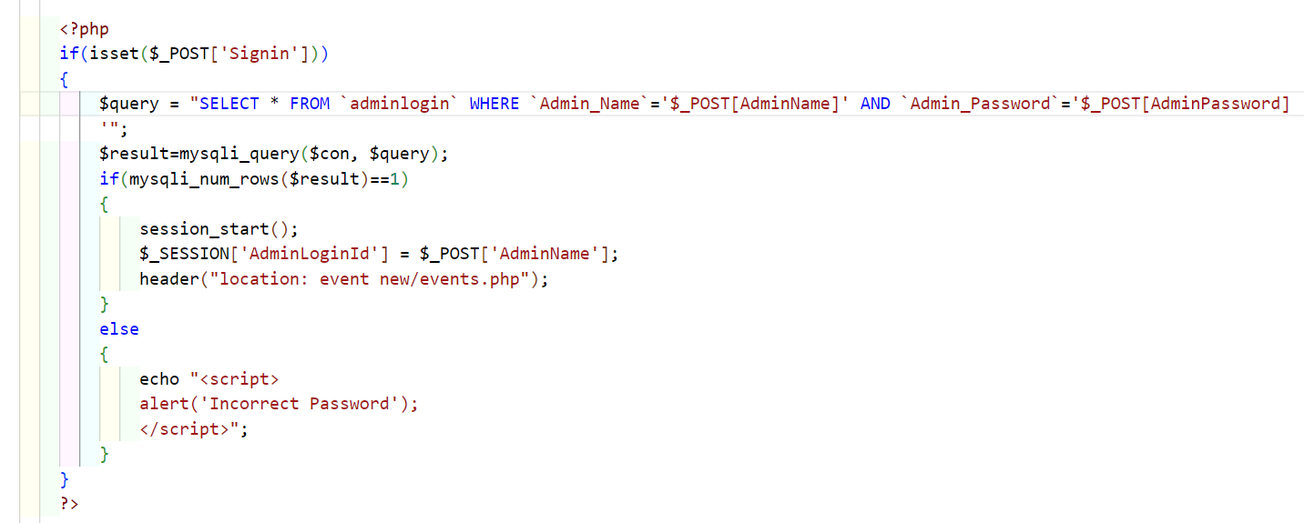Admin Login with set Id Password Validation & Database (phpMyAdmin) linking.

**Fig. 6.5.1: Log-In Logic**

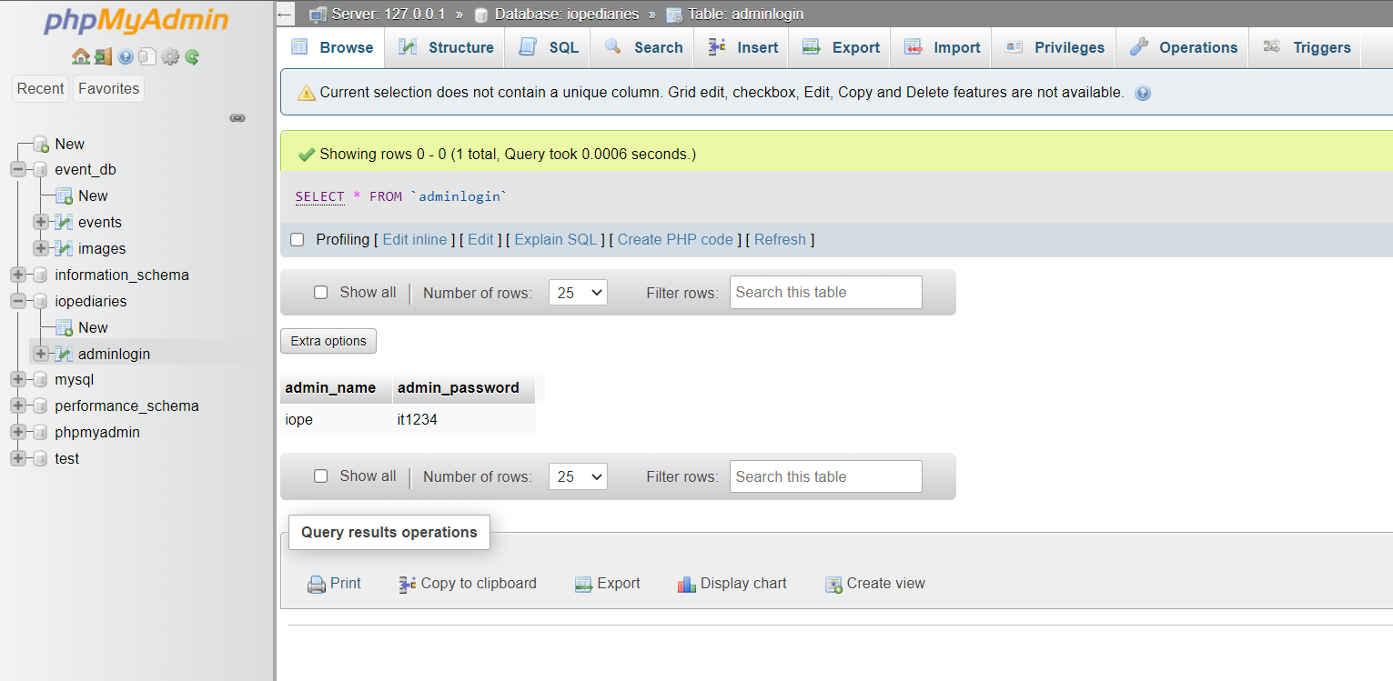

**Fig. 6.5.2: Log-In Logic (Database)**



* 1. **Meet the Team**

# Team CodeHolics 🔥

“None of us is as smart as all of us”

*- Ken Blanchard*



CodeHolics 🔥

“Great things are rarely achieved by just one person. Usually, they are accomplished by a group of people, and when everyone is committed to the overall goal, teams move faster, are more innovative and more successful. Successful teamwork is essential for anyone attempting complete projects successfully”

#### Team CodeHolics during their project work:

Team CodeHolics discussing and working on the project ‘IOPE Diaries’, in virtual meetings using Google Meet:

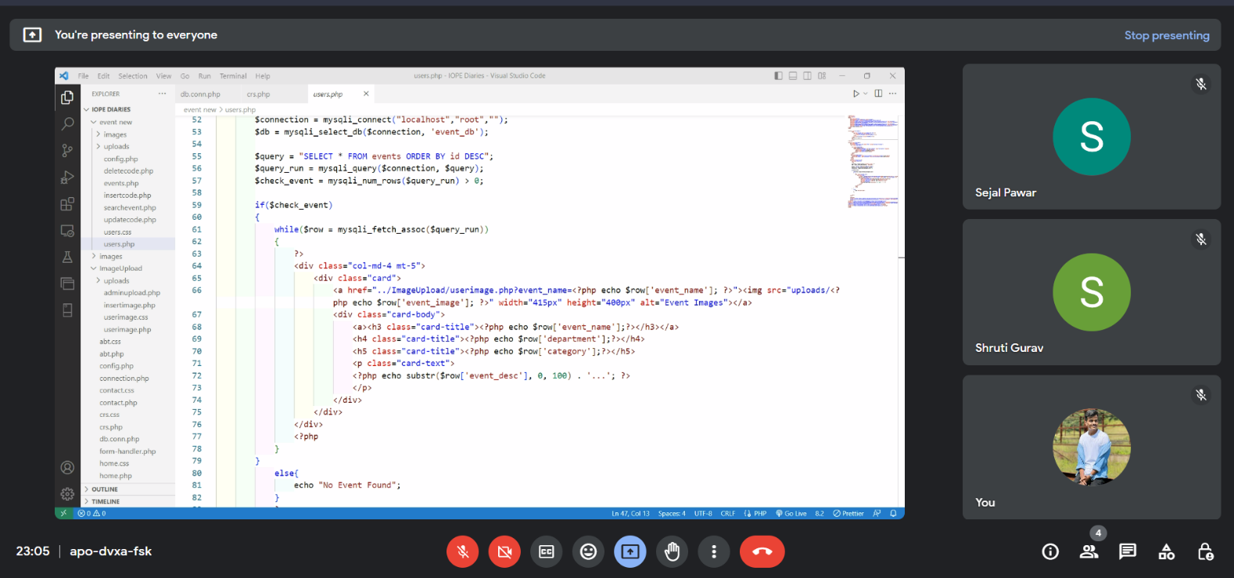

**Fig. 7.1: Project Meetings**

#### Roles of team members:

1. **Sejal Ravindra Pawar:** Team Leader, Back-end Developer & UI Developer.
2. **Manish Shashikant Jadhav:** Database Administrator.
3. **Shruti Sanjay Gurav:** Documentation.



**A CREATION BY**

**Team CodeHolics**

## CONCLUSION

In conclusion, the implementation of the event project in our college has significantly enhanced the overall event management experience for both the administrators and users. By introducing an intuitive interface, the project has provided a seamless platform for administrators to upload event details and associated images, while enabling users to access and explore these events conveniently.

The **“IOPE Diaries”** has proven to be an effective solution for streamlining the event displaying process within the college. Administrators now have the ability to effortlessly upload event information and images, reducing manual efforts and ensuring accuracy in event display. This centralized approach has facilitated efficient event organization and coordination, making it easier to keep the college community informed about upcoming events.

For users, the **“IOPE Diaries”** has brought about a user-friendly experience. Through the user event section, individuals can conveniently browse through various events hosted by the college. With just a click, users can access detailed event descriptions and captivating images, allowing them to make well-informed decisions about which events they wish to participate in.

By leveraging the **“IOPE Diaries”**, the college has successfully created an engaging and interactive event platform. The project's ability to display event details and images in a user-friendly manner will significantly increase user engagement and participation in college events. This, in turn, has contributed to a vibrant campus culture and fostered a sense of community among students, faculty, and staff.

In conclusion, the **“IOPE Diaries”** has revolutionized the way events are displayed and accessed

in our college. Its successful implementation has simplified event management, strengthened the college community. With ongoing maintenance and enhancements, the event project will continue to play a vital role in facilitating seamless event organization and fostering a dynamic campus environment.

## REFERENCES

<https://www.youtube.com/c/CodeWithHarry>

https://www.w3schools.com/php/

https://www.geeksforgeeks.org/php-tutorials/

https://www.geeksforgeeks.org/javascript/

https://getbootstrap.com/docs/5.0/getting-started/introduction/

https://youtu.be/XhFwXL0yE6E

https://fontawesome.com/

https://youtu.be/qgb_XqfwAec

https://youtu.be/WoftcZDfeoQ

https://cdn.datatables.net/

https://youtu.be/KljAKbOAY6M

https://youtu.be/onu3w8kqASU

https://youtu.be/mh4MVFiMZTM

<https://youtu.be/oOL--VASs8Q>

https://youtu.be/znqUwx0b0HI